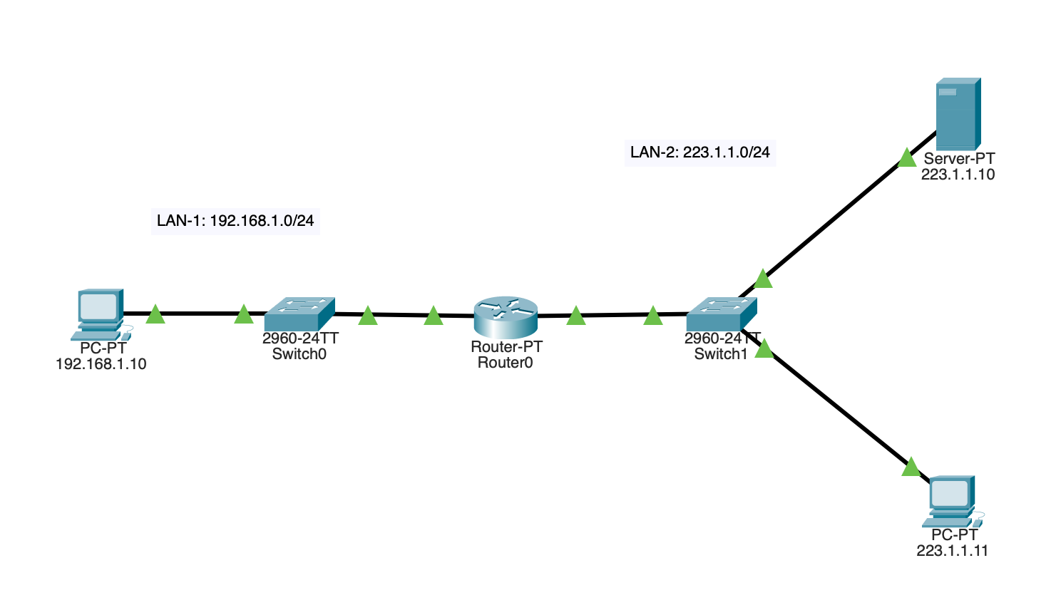

Create this network in Packet Tracer. Configure the PCs, server and router appropriately. Remember to set the default gateways for the end devices.